Workshop 8 - Software Defined Networking (SDN)
- Introduction
Packet tracer is available on APPS Anywhere and will use this to construct a network that services two buildings in a company, East and West. We will configure the network devices with some basic settings in order that the network controller can talk to them over the network, and then use this to apply some centrally defined control over these, while also acquiring a picture of the performance of these and their hosts.

- Construct the following network
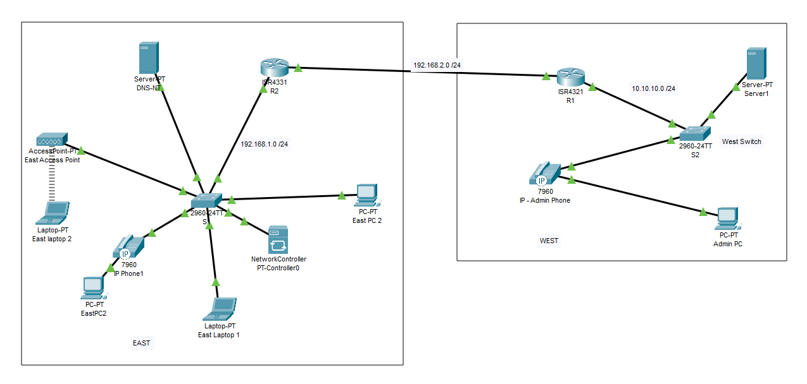
Construct the following network from the pallet with the devices in the list below, and set their IP address as follows.
EAST
Name | IP Address | Default gateway | Port connected to on switch
Server-PT DNS-NT | 192.168.1.8 | 192.168.1.1 | F0/1
East Access-Point-PT |  |  | F0/2
East wireless Laptop-2 | 192.168.1.3 | 192.168.1.1
East PC2/ | 192.168.1.4 | 192.168.1.1 | Through IP phone to F0/3
East laptop 1 | 192.168.1.5 | 192.168.1.1 | F0/4
Network Controller | 192.168.1.7 | 192.168.1.1 | F0/5
East PC2 | 192.168.1.6 | 192.168.1.1 | F0/6
Router – R2 - G0/0 | 192.168.1.1 /24 |  | Switch 2 G0/1
Router – R2 - G0/1 | 192.168.2.1 /24
West
Name | IP Address | Default gateway | Port connected to on switch
Router – R1 G0/0 | 192.168.2.2 /24
Router – R1 G0/1 | 10.10.10.1 /24 |  | F0/1
Server - PT | 10.10.10.4 /24 | 10.10.10.1 | F0/2
Admin - Pc | 10.10.10.3 | 10.10.10.1 | Through Phone to F0/3

- Configure S1, S2 R1 and R3
On Routers R1 and R2 apply RIP as a routing protocol along with suitable Network statements. Check using the ping command from any workstation or laptop that full connectivity is available across the network.
On switches 1 and 2 we need to undertake some basic configuration.
Switch(config)# hostname S1
S1(config)# interface Vlan 1
S1(config-if)# ip address 192.168.1.2 255.255.255.0
S1(config-if)#no shutdown
S1(config-if)#interface g0/0
S1(config-if)#switchport mode trunk
S1(config-if)#no shutdown
S1(config-if)#exit
S1(config)#ip default-gateway 192.168.1.1
And
S2(config)# interface Vlan1
S2(config-if)# ip address 10.10.10.2 255.255.255.0
S2(config-if)#interface g0/0
S2(config-if)#switchport mode trunk
S2(config-if)#no shutdown
S2(config-if)#exit

S2(config)#ip default-gateway 10.10.10.1

We need to set an enable password, and in order that the network controller can connect to the switch it must be configured to accept SSH command line interface connections. It will require a username and password.
S1(config)#enable password class
S1(config)#username [your student number ] password [your student number ]
The following will generate some asymmetric keys to allow SSH communication
S1(config)#ip domain-name 6cs029.com(http://6cs029.com/)
S1(config)#crypto key generate rsa general-keys modulus 1024
S1(config)#ip ssh version 2
We now must configure the switch such that it accepts input via up to 5 virtual connections (i.e. over the network). And force the use of the enable password
S1(config)#line vty 0 4
S1(config-line)#login local
S1(config-line)#transport input ssh

We need to repeat these last 8 lines of code for SW2, R1 and R2.

- Network Controller Configuration
We will configure the controller such that you can access it outside of Packet tracer. Set the HTTP controller port to 58000, and Tick Access enabled.
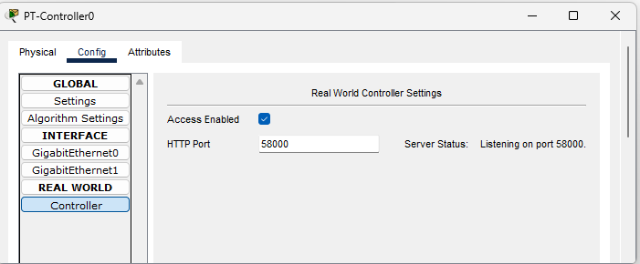
Now open a browser on the admin PC and set the URL as shown, this will force you to create a new user on the controller
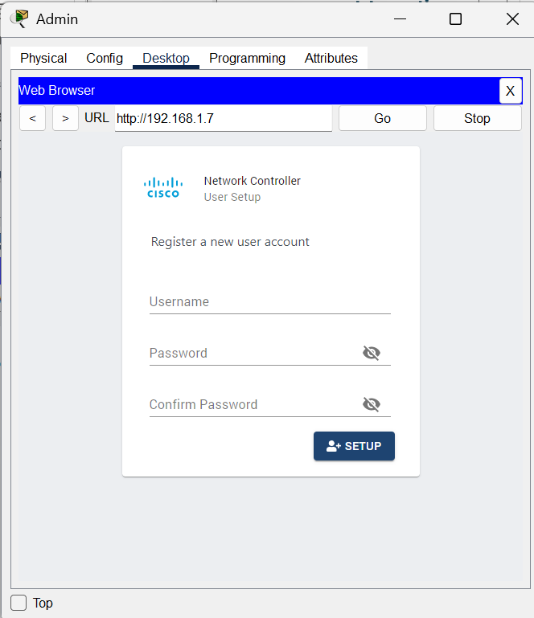
Set the Username as admin, and the password as Your Student Number
Now login as admin
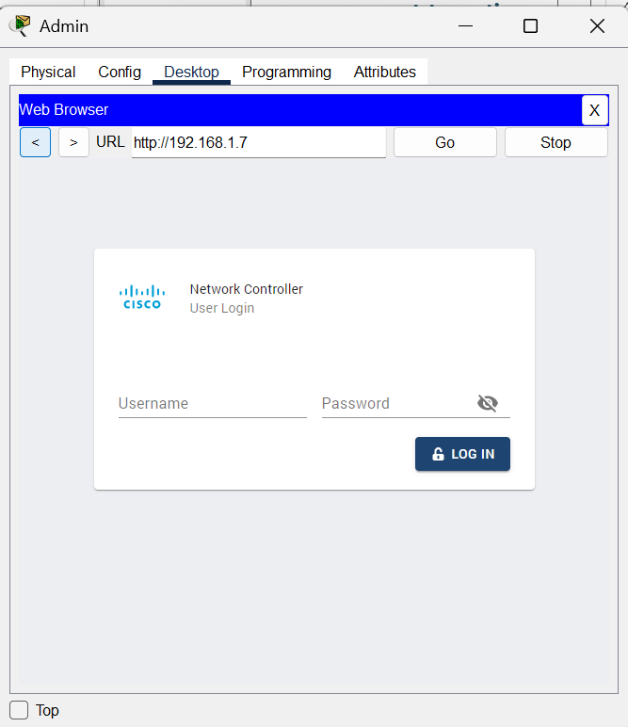

The initial dashboard will appear, but this has no information about the network or devices.

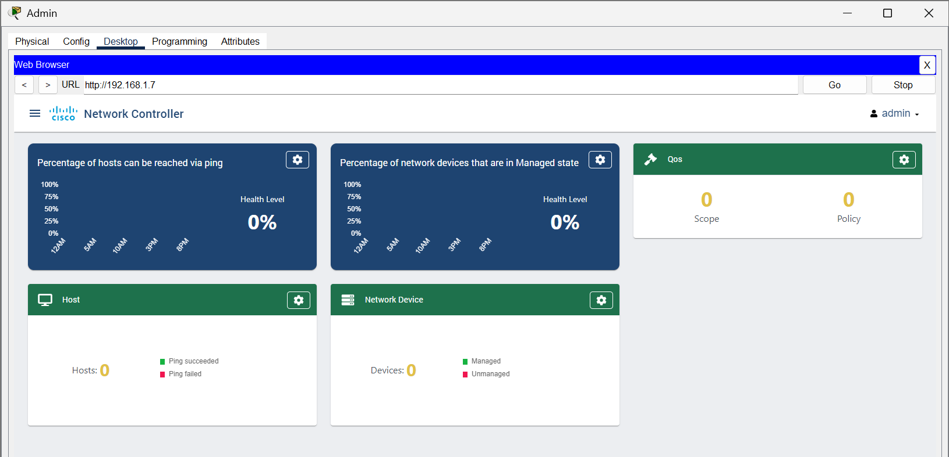

We need to populate the controller with devices, which is called provisioning. Select from here

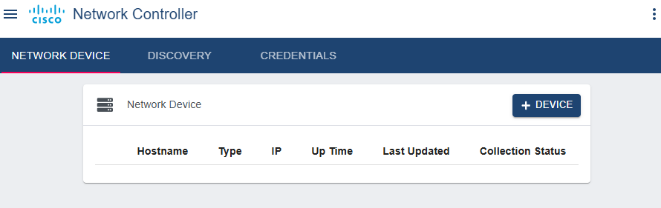

We need to create a credential list to log into the devices. From the top menu select credentials and then +credential from the pop up and fill in the user and passwords. You have initially configured that all the network devices have the same login usernames and passwords, and then we use these (credentials) to start to capture the devices in the Network Controller API.
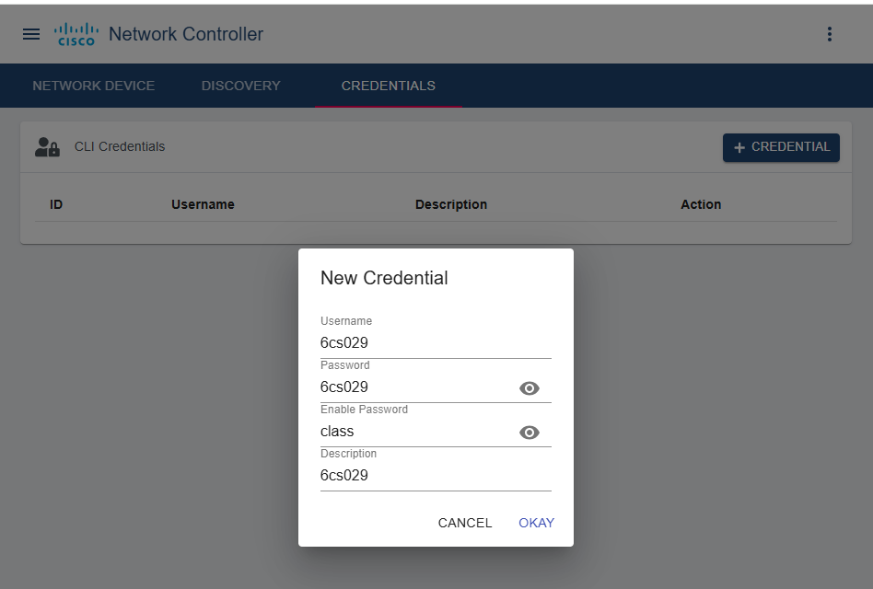
Select the menu item Network device, and then +device. Set the Ip address of the device and select the credentials for the drop down menu.
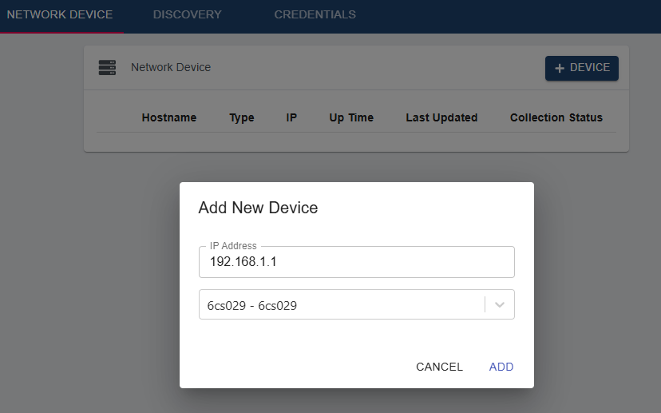
Repeat this for all devices
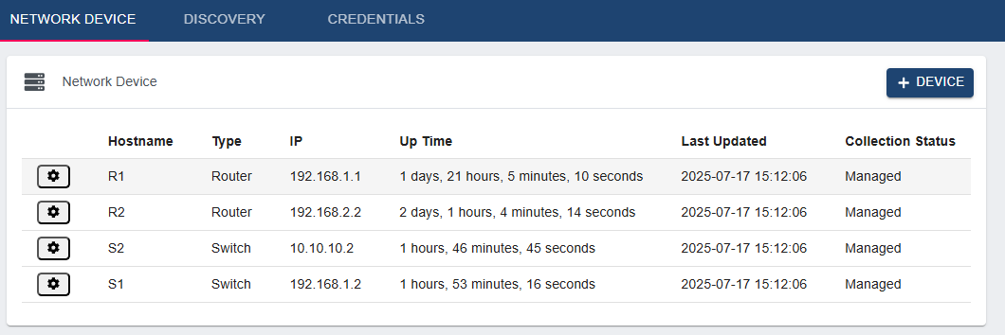

Discovery
This option will give us more details about the state of our devices
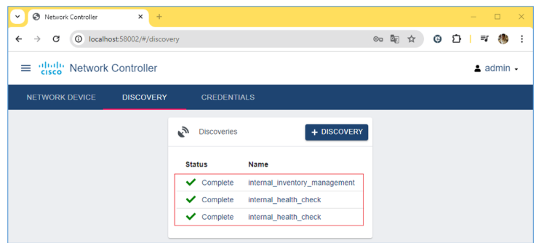
We will select the west part of network to check the state of the devices and links. Select discovery and fill in the pop up with the IP range of the devices
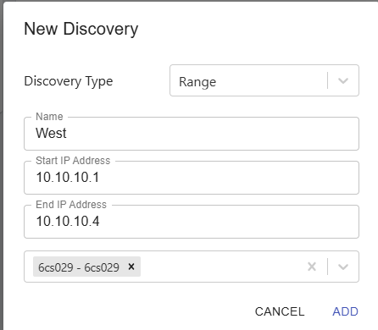
Repeat this for the east area

Now select from the list to see the state of the devices
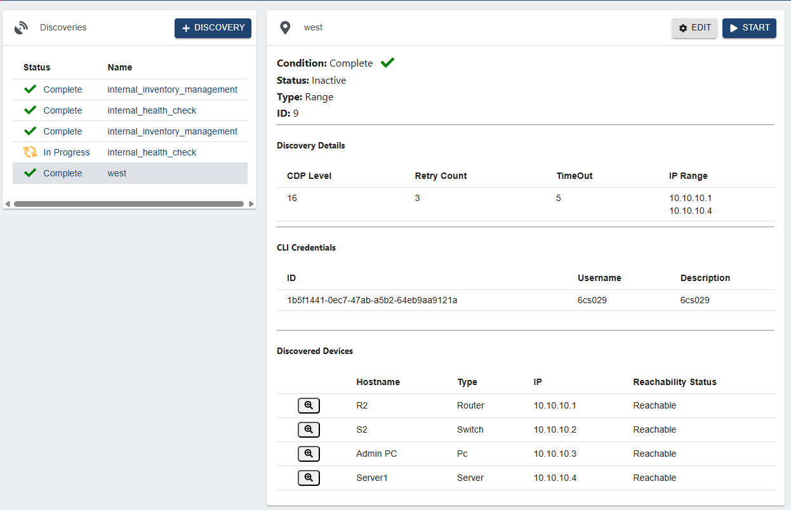

Assurance
Will give us a pictorial view of the overall state of our network devices
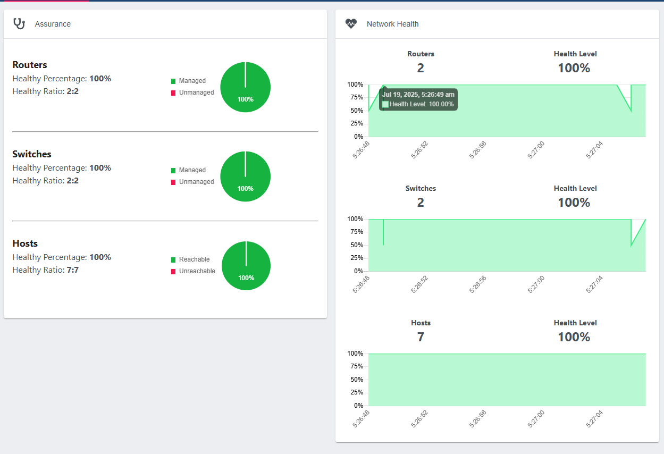
Hosts option will show us the details of these
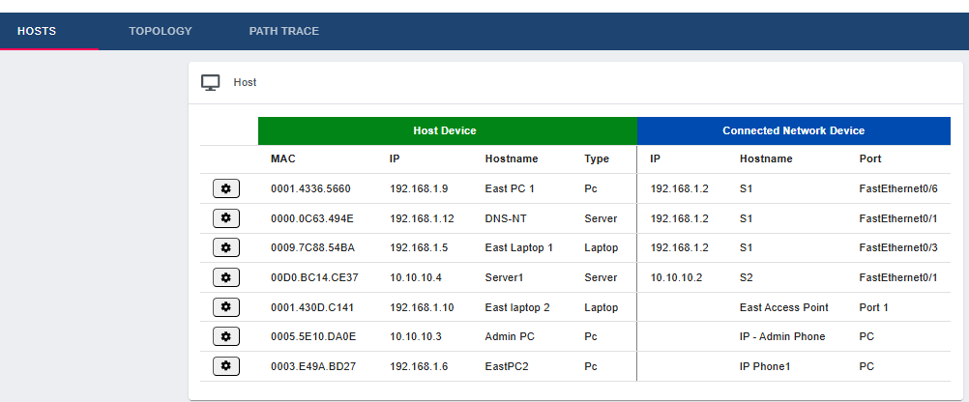

Topology option will show us the network topology of switches and routers
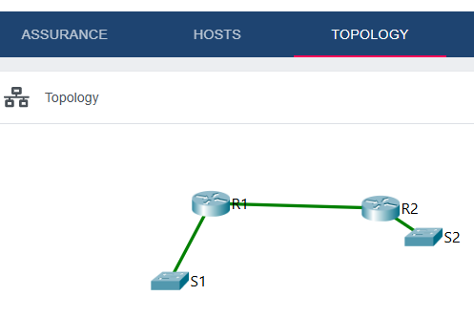

The path option will show the path traffic goes through between two devices
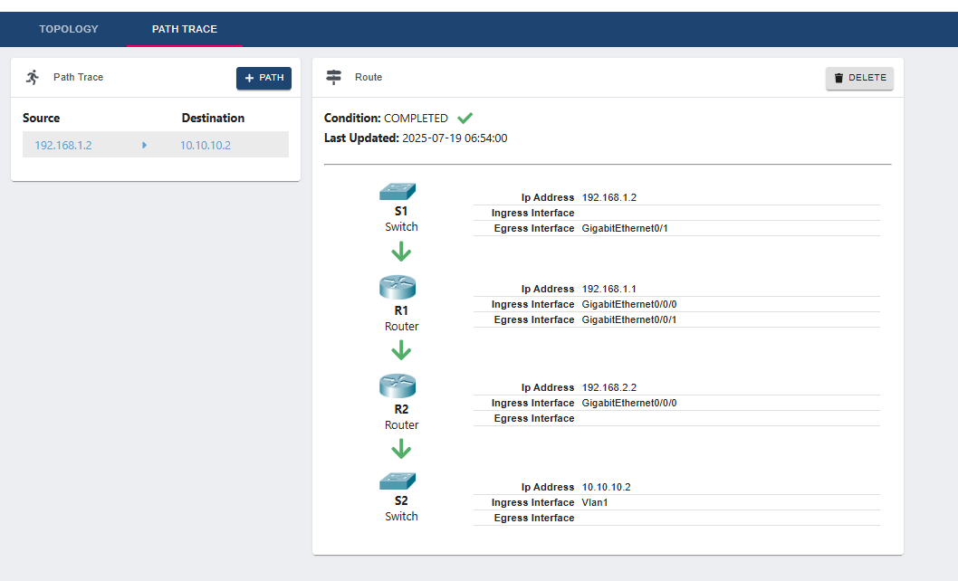

Dashboard
From here we can get an overview of our devices
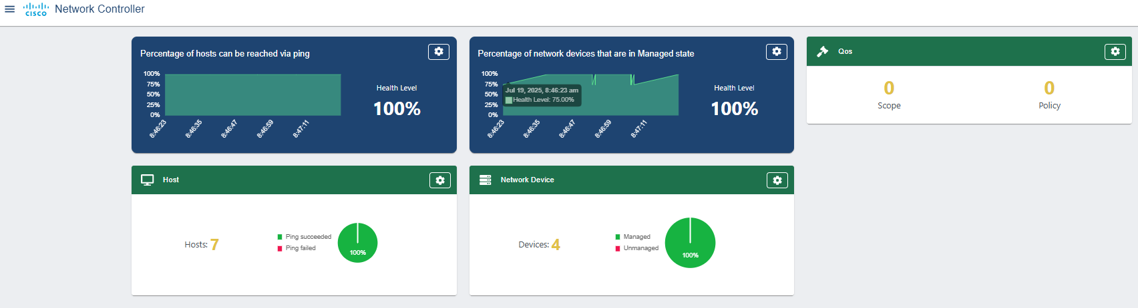
In order to configure the network devices we will push a centralised configuration using “PUSH CONFIG” option. We will set network devices to connect to the server running NTP and SYSLOG so we can coordinate timing and log to it. Select the settings button on the QOS window, then NTP tab and add the NTP servers address and click save. Repeat this for the SYSlog tab
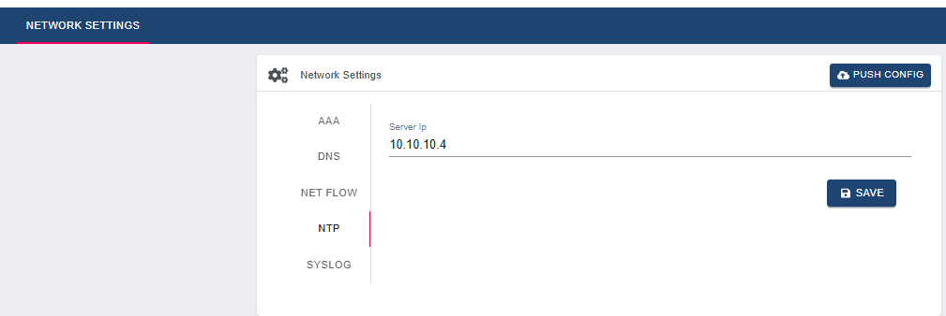

Now use the PUSH CONFIG and the summary will appear.
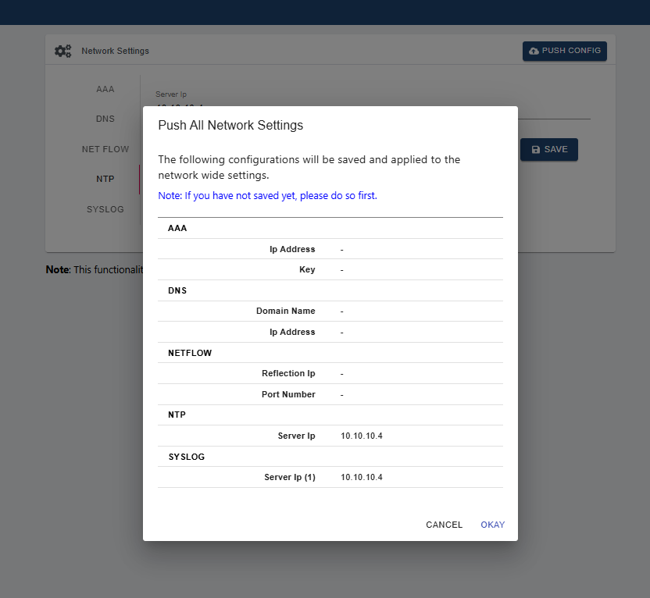
Click okay and this will be pushed to the four network devices.
To test if this has worked shutdown the g0/0 interface on EAST switch, and then bring it back on line again. Check the SYSLOG entries to confirm this has been logged.

Demonstrate to your tutor

